Assignment –7 Summarizing Data with Aggregate Functions.

1. Write a query that counts all orders for October 3.

Ans. mysql> select count(*) from orders where odate = '1990-10-03';

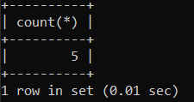

1. Write a query that counts the number of different non-NULL city values in the Customers table.

Ans. mysql> select count(distinct city) from customers where city is not null;

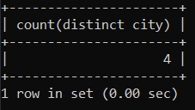

1. Write a query that selects each customer’s smallest order.

Ans. mysql> select customers.cnum, customers.cname, MIN(orders.amt) as smallest_order from customers

-> join orders on customers.cnum = orders.cnum

-> group by customers.cnum, customers.cname;

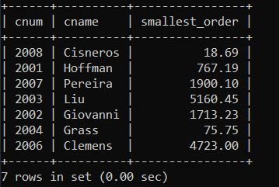

1. Write a query that selects the first customer, in alphabetical order, whose name begins with G.

Ans. mysql> select * from customers where cname like 'G%' order by cname limit 1;

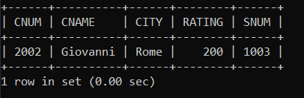

1. Write a query that selects the highest rating in each city.

Ans. mysql> select city, max(rating) as highest_rating from customers

-> group by city;

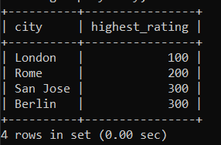

1. Write a query that counts the number of salespeople registering orders for each day. (If a salesperson has more than one order on a given day, he or she should be counted only once.)

Ans. mysql> select odate, count(distinct snum) as unique_salespeople

-> from orders

-> group by odate;

